# Project Submitted By

|  |  |  |  |  |
| --- | --- | --- | --- | --- |
| Name | College Name | Branch | Email | Expected  Degree  Completion Year |
| Tanmay Kandekar | Samarth College of Engineering &Management | Computer  Engineering | Tanmaykandekar269@  gmail.com | 2026 |
| Vaishnav  Mavale | Samarth College of Engineering &Management | Computer  Engineering | Mavalevaishnav2004@  gmail.com | 2026 |

Project Code

45DP130

Project Name

Customer Feedback Analysis

# Abstract

Customer feedback analysis plays a crucial role in understanding customer satisfaction, identifying areas for improvement, and enhancing business performance. This project focuses on developing a system for analyzing customer feedback using natural language processing (NLP) and machine learning techniques. The system collects feedback from various sources, such as surveys, social media, and online reviews, and processes it to extract key insights, such as sentiment analysis, common themes, and customer concerns.

Domain

Machine Learning and data science

Technologies Used

Python, NumPy, Matplotlib, Scikit-Learn

# Tools Used

Kaggle Notebook, Python, Scikit-Learn, Pandas, NumPy, Matplotlib, Scikit-Learn: StandardScaler, Logistic Regression, Train-Test Split, Classification Metrics.

Project Link (if the project is hosted somewhere)

Not applicable

# Instructions to run the project

1. **Create a New Notebook** → Go to [Kaggle](https://www.kaggle.com/) → Click **"New Notebook"**.
2. **Install Dependencies** (if needed) → Run:
3. python
4. CopyEdit
5. !pip install scikit-learn pandas
6. **Upload the Script** → Click **"Add Data"** → **"Upload"** → Select customer_feedback_analyzer.py.
7. **Run the Script** → In a new cell, execute:
8. python
9. CopyEdit
10. %run /kaggle/input/YOUR_FILENAME/customer_feedback_analyzer.py
11. *(Replace YOUR_FILENAME with the uploaded folder name).*
12. **Interact with the Model** → Enter feedback and check predictions!

# Output Images / Screenshots / Files

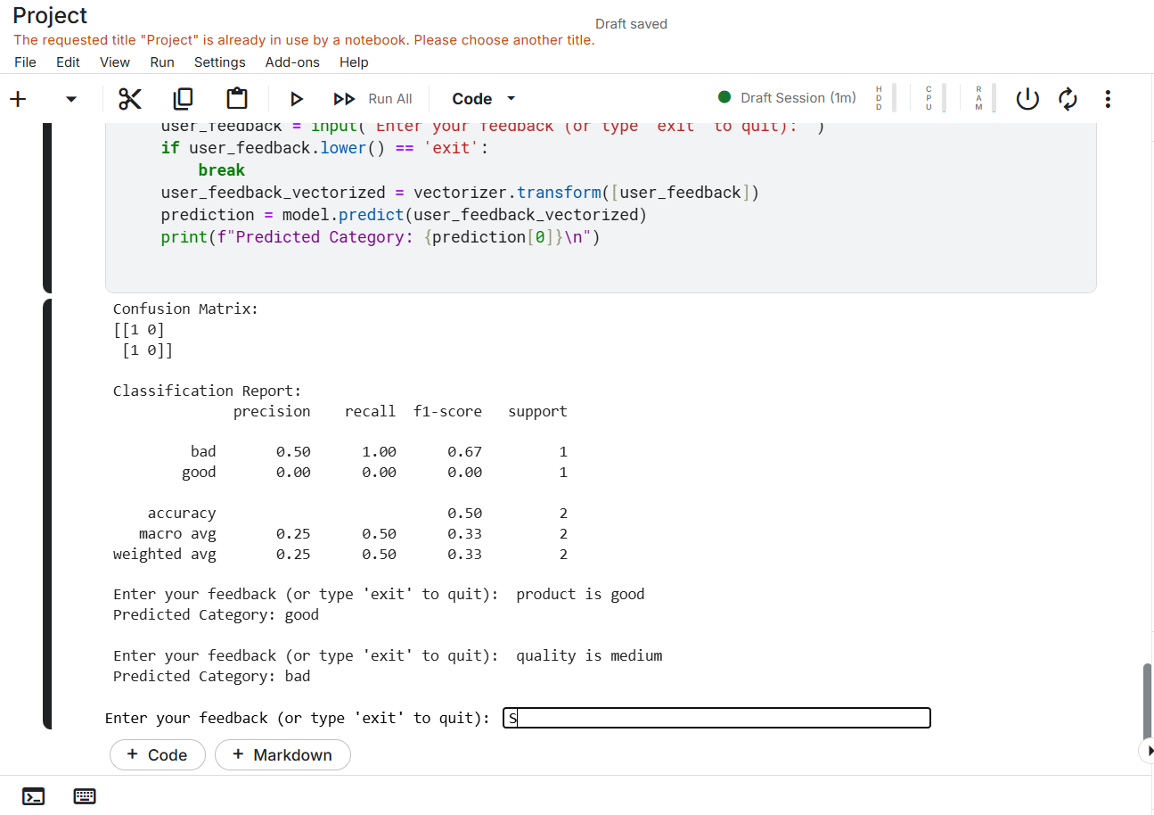

https://www.kaggle.com/code/tanmaykandekar/notebookf2051b5205